IYPT2026
01 Invent Yourself / 自己发明
A self-starting siphon can be made using a piece of rigid tubing bent into a specific shape. When the siphon is partially immersed in water, it begins siphoning water without the need for initial suction. Investigate how the relevant parameters, such as the geometry, affect the siphoning process. / 一种自启动虹吸管可通过将刚性管弯曲成特定形状制成。当此虹吸管局部浸入水中时，无需初始抽吸即可开始虹吸。研究相关参数(如几何形状)对虹吸过程的影响。
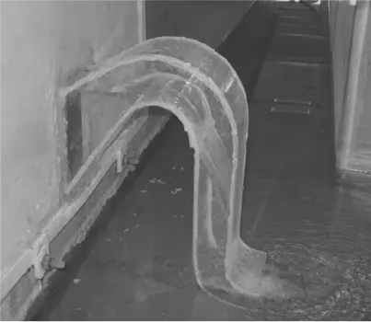

02 Electrical damping / 电阻尼
A magnet suspended by a spring will display simple harmonic motion when displaced. If the magnet oscillates within a coil connected to a resistor, its motion will be damped. Investigate the factors that affect the damping. / 一个悬挂在弹簧上的磁铁在发生位移时呈现简谐运动形式。若此磁铁在与电阻相连的线圈内振动，其运动会受到阻尼。探究影响阻尼效果的因素。
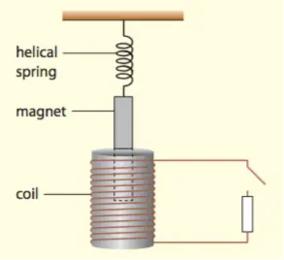
03 Ring fountain / 环形喷泉
When a flat metal ring falls from a certain height into a water tank, it generates a fountain that can shoot water high into the air. How does the maximum height of the fountain depend on the ring’s parameters? / 当一扁平金属环从一定高度落入水箱时，会形成一道向空气中喷射水流的喷泉。此喷泉的最大高度如何取决于金属环的参数？
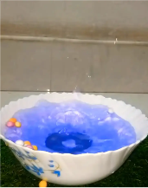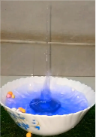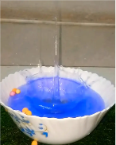

04 Oil flow / 油流
A thin layer of cooking oil on a flat metal surface flows outwards when heated. Investigate the phenomenon and its dependence on relevant parameters. / 平坦金属表面的食用油薄层在受热时会向外流动。研究该现象及其与相关参数的依赖关系。
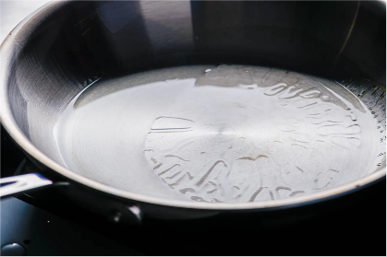

05 Elastic wave dynamics / 弹性波动力学
Suspend a metal ball from a fixed support using a rubber band and twist it many times around its vertical axis. When the ball is released, standing waves are formed on the rubber band. Investigate this phenomenon and study how the wave depends on relevant parameters. / 用橡皮筋将一金属球悬挂在固定支架上，并绕其竖直轴多次扭转。当松开金属球时，橡皮筋上会形成驻波。研究这一现象并探究波的特性与相关参数的依赖关系。
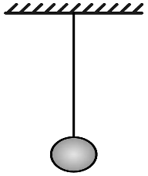
06 Flipo Flip / 翻转玩具
A Flipo Flip toy can roll for multiple turns even though its shape is not circular. Investigate how its motion depends on parameters such as geometry and the initial release conditions. / Flipo Flip玩具能滚动多圈，即使其形状并非圆形。研究其运动如何依赖于相关参数，例如几何参数及初始释放条件。
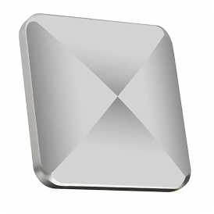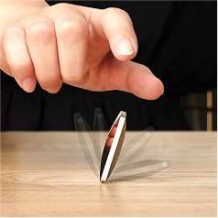
07 Tennis racket theorem / 网球拍定理
When an object with different principal moments of inertia about each axis is thrown while it rotates, it can suddenly start rotating around an axis different from the one it was initially rotating about. Investigate how the rotational motion of such an object is affected by relevant parameters during its free fall. / 当一个物体各主轴的主转的物体在旋转的时候被抛出，它可能会突然开始绕一个与最初旋转不同的轴旋转。研究在自由下落过程中，这类物体的旋转运动如何受到相关参数的影响。
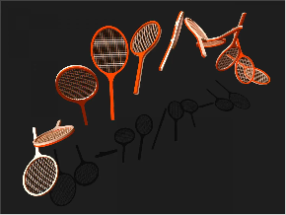
08 Magnetic accelerator / 磁铁加速器
Fix magnets in pairs onto a metal sheet as shown. If you attach two magnetic discs onto an axle this “vehicle” will accelerate over the rows of magnets under certain conditions. Investigate the phenomenon. / 如图所示，成对的磁铁放置到金属板上。如果你将两个圆柱磁安装到一个轴上，这个“车辆”将会在特定条件下在这一排排磁铁上加速前进。探究这一现象。
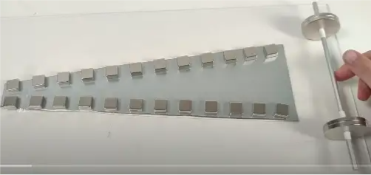

09 Levitation control / 控制悬浮
When arranged in a specific configuration, small graphite sheets can levitate on neodymium magnets. By shining light onto the surface of the graphite sheet, it is possible to control its movement. Explain and investigate the phenomenon. / 当以特定方式排列时，小块的石墨片可以在钕磁铁上悬浮。通过将光照射到石墨片的表面，可以控制其运动。解释并研究这一现象。
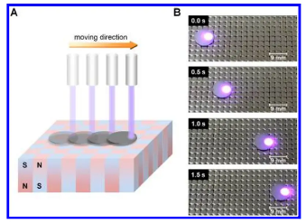

10 Submerged crater / 水下陨石坑
If you release sand or similar granular material in a container filled with water, the material will sink to the bottom and may form a crater-like structure. Explain and investigate the phenomenon. / 若将沙粒或类似颗粒材料释放至盛满水的容器中，材料将沉至底部，并可能形成坑状结构。解释并研究该现象。

11 Sweet monochromator / 甜蜜的单色仪
Pass linearly polarised white light through a column of sugar solution. When transmitted light is observed through a polariser it may appear coloured. Rotate the polariser, and the transmitted light colour may change. Construct such a sweet monochromator and optimise for the narrowest light wavelength bandwidth. / 让线偏振的白光通过一根充满糖溶液的柱状容器。当透射光通过偏振片观察时，它可能呈现出彩色。旋转偏振片时，透射光的颜色也可能发生变化。搭建这样的一个单色仪并优化其最窄的光谱带宽。
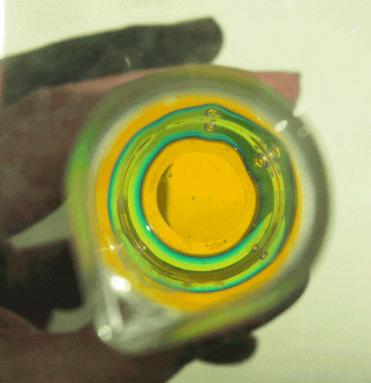

12 Autumn coin / 如叶之坠
The motion of a coin falling to the bottom of a tank filled with liquid can be remarkably similar to the fluttering and tumbling of a falling autumn leaf. Investigate how the motion of the coin depends on relevant parameters. / 一个硬币沉到充满液体的水缸里时，其运动与一片扑动(fluttering)飘落(tumbling)的树叶的颤动和翻滚的状态惊人地类似。解释硬币的这种运动如何依赖于相关参数。
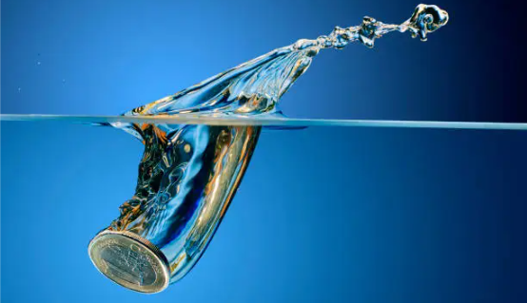
13 The singing ruler / 尺子之歌
When a ruler is clamped at one end and struck, it oscillates and emits a characteristic sound. Investigate how the sound depends on relevant parameters. / 当尺子的一端被夹住固定并敲击时，它会振动并发出特有的声音。研究这种声音如何取决于相关参数。
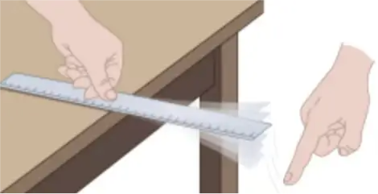
14 Crystal Critters / 晶体小精灵
Observe the evaporation of a drop of table salt solution on a warm hydrophobic surface. After the water evaporates, a variety of characteristic crystal shapes remain. Research and explain this phenomenon. / 观察一滴食盐溶液在温暖的疏水表面上的蒸发过程。水蒸发后，会留下各种特征的晶体形状。研究并解释这一现象。
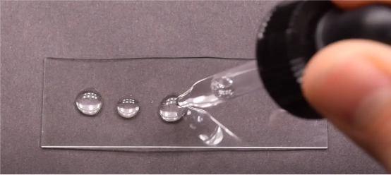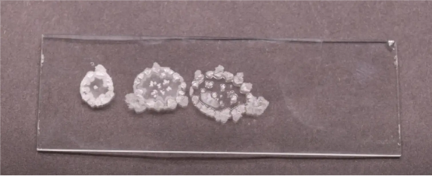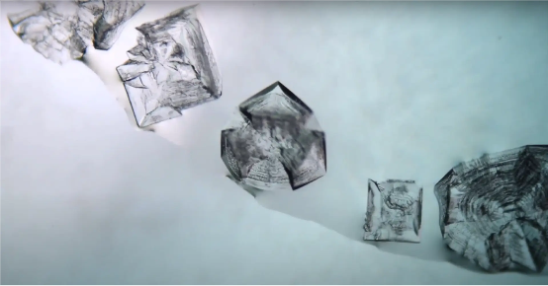
15 Magnetic Newton’s cradle /磁力牛顿摆
Repulsing, non-touching magnets are used instead of colliding balls to make a new type of Newton’s cradle. The new cradle can act in a similar way to a regular cradle, but can also exhibit other interesting behaviour. Explain and study the movement of this magnetic cradle. / 用相斥的非接触磁体替代碰撞的球体，制成新型牛顿摆。该装置既可模拟常规牛顿摆的运动，也能呈现其他有趣行为。解释并研究此磁力摆的运动规律。
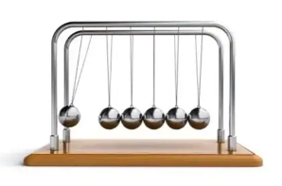
16 Twisted spaghetti / 扭转的意面
When a bundle of spaghetti is twisted, it might withstand higher transverse (side) forces than a straight, untwisted bundle. Investigate the response of a twisted bundle to transverse stress and identify the optimal twist that maximises tolerance to transverse stress. / 当一束意面被扭转时，其承受横向(侧向)力的能力可能强于未扭转的直面条束。研究扭转面束对横向应力的响应，确定最大化横向应力耐受下的最佳扭转方式。
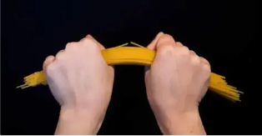
17 Travelling flame / 行进之焰
A flame can propagate continuously around a ring-shaped trough containing a thin layer of flammable liquid. Investigate how the characteristics of this travelling flame depend on relevant parameters. / 在装有薄层可燃液体的环形槽中，火焰可以在其上持续环绕传播。研究该行进火焰的特性如何依赖于相关参数。
